* A tautology is a statement that is always true.
* A contradiction is a statement that is always false.
* A contingency is a statement that can be either true or false, depending on the situation.

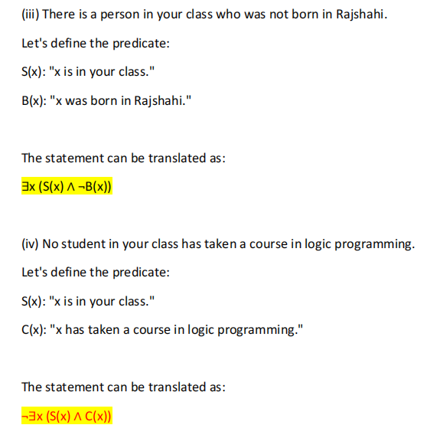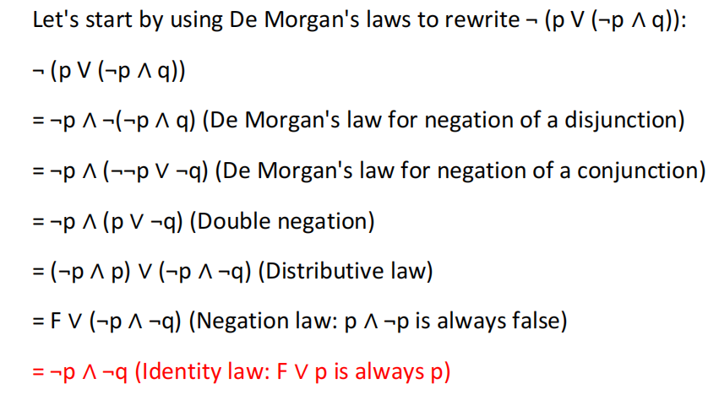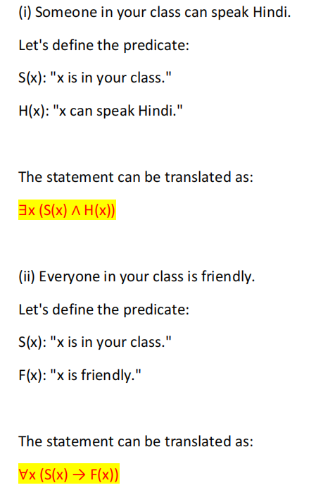For example, the statement "It will rain tomorrow".

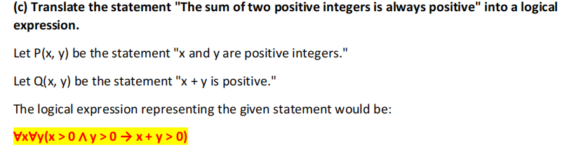

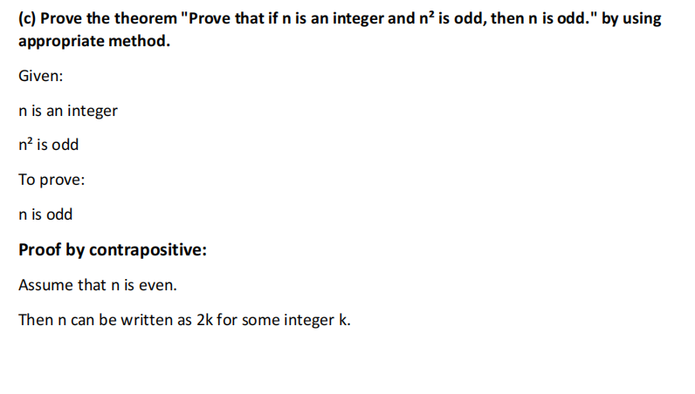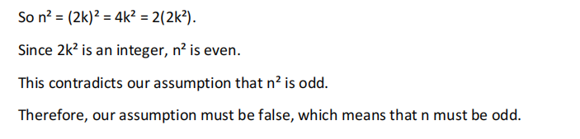

The "fallacy of denying the hypothesis" occurs when someone concludes that because the hypothesis of a conditional statement is false, the conclusion must also be false. This is a logical error because it ignores other possibilities.

A **poset** (short for **partially ordered set**) is a set P combined with 3 binary relation

**Reflexivity**: **Antisymmetry**: **Transitivity**:

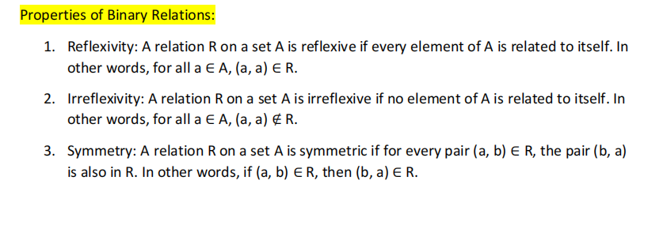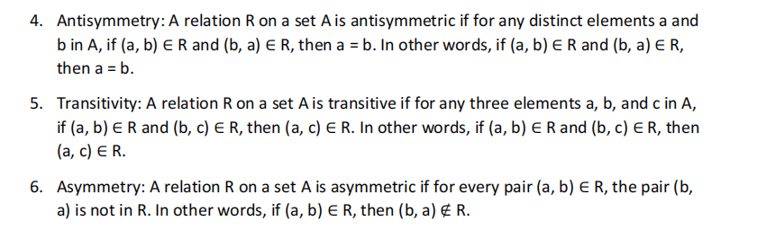

The n-Cube graph, also known as the hypercube graph or the n-dimensional cube graph, is a graph that represents the corners and edges of an n-dimensional hypercube.

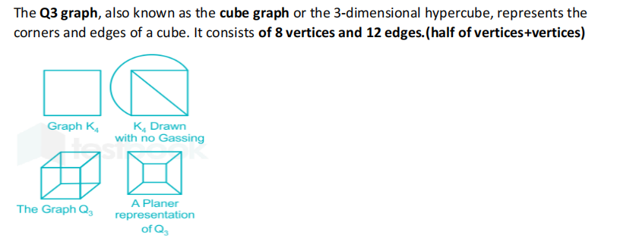

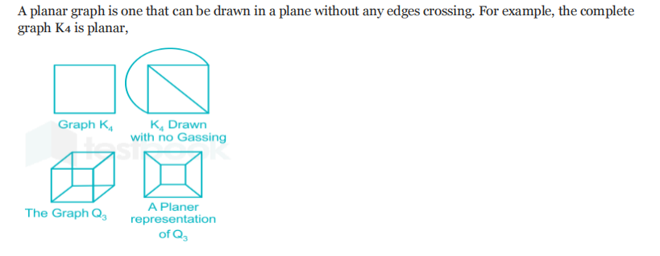

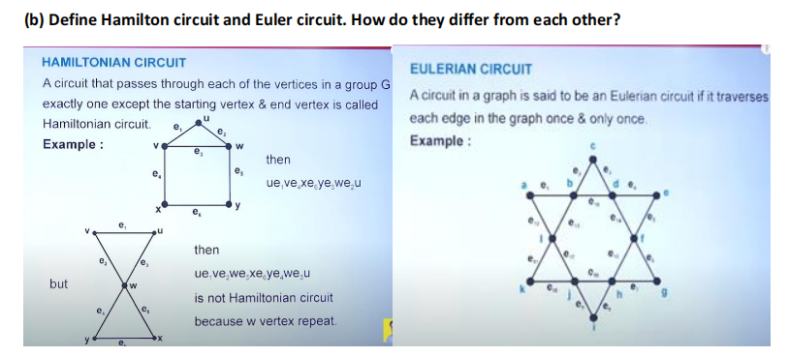

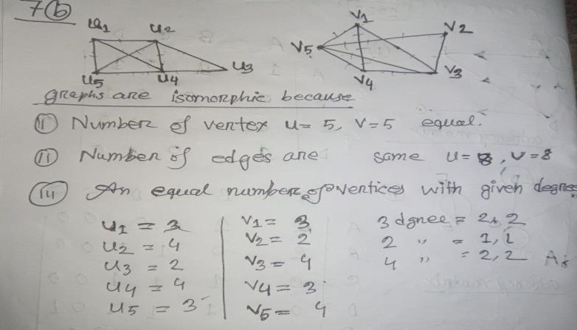

A logical equivalence means that the two sides always have the same truth values.

A bit string is a series of Boolean values that ith bit represent ith number.

A quantifier is “an operator that limits the variables of a proposition”.

A partially ordered set in which pair of elements has both a least upper bound and a greatest lower bound is called **lattice**.